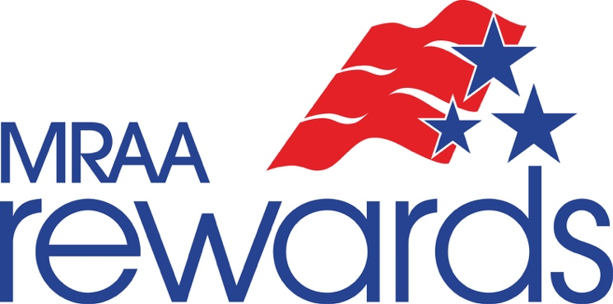

A Free Resource of the Marine Retailers Association of the Americas.

Service Authorization Form

All retailers who conduct service business should require their customers to sign a Service Authorization Form to outline the liabilities held by the customer. Through our friends at Bellavia, Blatt & Crossett, we have developed the following document available for your use. Simply brand this with your dealership's name or logo, and contact information, where indicated on the form, and this can serve as your guide in creating such a document.

MRAA disclosure: The following document is a sample only. This document is subject to change and may be changed in order to comply with applicable state and federal law. MRAA nor any of its affiliates, representatives, legal counsel or other parties make no representation to its validity in your jurisdiction. Please contact legal counsel should you have any questions to its validity in your jurisdiction.
If you are interested in exploring the services of Bellavia, Blatt & Crossett and view more information about their services here: Legal Services. For when legal needs appear, the MRAA has arranged an agreement with Bellavia, Blatt & Crossett, whose legal advisors are on standby to provide marine dealers like you with advice on subjects such as dealer agreements, real estate and lease agreements, employment practices, consumer complaints and more.
[INSERT DEALER NAME]
Service Authorization

Date:_____/_____/_____
Customer Name:________________________________________________________________
Address:_______________________________________________________________________
Phone Numbers:________________________________________________________________
Email Address:__________________________________________________________________
Vessel Make/Model:_____________________________________________________________

Description of repairs to be performed:______________________________________________
______________________________________________________________________________
______________________________________________________________________________
______________________________________________________________________________

Authorization for Repairs: Your signature below serves as your acknowledgment of the following: 1) You authorize this dealership to proceed with the repair work requested above; 2) You agree that the dealership is not responsible for a) delays caused by unavailable parts b) loss/damage to the vessel or to articles left in the vessel due to fire, theft, vandalism, or freezing; 3) You grant permission for dealership employees to operate the vessel for the purpose of testing and/or inspection; 4) An express chattel lien is asserted by this dealership for the labor performed and materials furnished with respect to your vessel; 5) You have insurance covering the above-referenced vessel that you will maintain throughout the time that the vessel is being repaired by the dealership; and 6) Failure to claim your vessel within one week of the completion of repairs will result in a daily storage fee of $10.00.

_______________________________________________ ______________________
Customer Signature Date

