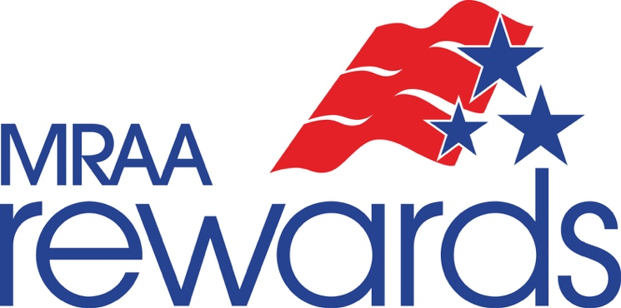

***A Free Resource of the Marine Retailers Association of the Americas.***

**As Is – No Warranty Form**

All retailers who sell used or consigned boats need to consider if they are willing to perform warranty work on that vessel and there are times when you may want to provide an “As Is - No Warranty” disclaimer. Through our friends at Bellavia, Blatt & Crossett, P.C., we have developed the following document available for your use. Simply brand this with your dealership's name or logo, and contact information, where indicated on the form, and this can serve as your guide in creating such a document.

**MRAA disclosure**: The following document is a sample only. Since it’s a Word document, it can be edited as necessary.  Dealers should retain a signed copy and give another copy to the purchaser. Be advised that this is a generic form that has been created not knowing what states it will be used in.  In some states “as is” sales are allowed only if specific action is taken or certain language is used. Please contact legal counsel should you have any questions to its validity in your jurisdiction, so that you can ensure that you are abiding by state laws.

This document is subject to change and may be changed in order to comply with applicable state and federal law. MRAA nor any of its affiliates, representatives, legal counsel or other parties make no representation to its validity in your jurisdiction.

If you are interested in exploring more information about the legal services offered by Bellavia, Blatt & Crossett, P.C. click here: [**Legal Services**](http://www.mraa.com/default.asp?page=MRAADealerLaw). Through a special arrangement that the MRAA has developed with the firm, a $300 monthly retainer with Bellavia, Blatt & Crossett, P.C. can provide your dealership with unlimited access to legal support on a variety of matters including franchise agreements, employment practices, consumer complaints, real estate and lease agreements, and more.

**BUYER’S GUIDE**

IMPORTANT: Spoken promises are difficult to enforce. Ask the dealer to put all promises in writing. Keep a copy of this form.

_____________________ __________________ _________ ______________________________

Vessel Make Model Year VIN / Hull Number

_____________________________________

Dealer Stock Number (optional)

**WARRANTIES FOR THIS VESSEL:**

🞏 AS IS – NO WARRANTY

YOU WILL PAY ALL COSTS FOR ANY REPAIRS. The dealer assumes no responsibility for any repairs regardless of any oral statements about the vessel.

____________________ ___________________ ___________

Customer Signature Printed Name Date

[insert dealer name/address information here]