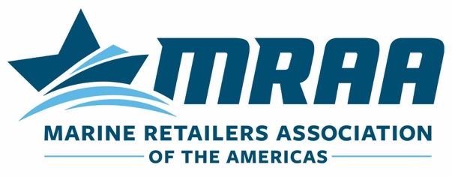

Sample Email You Can Use to Notify Your Dealers of the Importance of the Forthcoming Dealer-Manufacturer Survey

Highlighted areas should be updated by Manufacturer.

Dear DEALER,

__Brand__ greatly values the relationship we maintain with you and your business. As we continue to look ahead to how, together, we can take better care of our mutual customers and grow our businesses, __Brand__ would value your feedback on how we are performing in relation to your expectations for us as your chosen partner. With this mind, we are launching, in partnership with the MRAA, a Scorecard/Performance Review initiative to gather dealer feedback and take a look at what we can do to improve our performance, strengthen our relationship with you, and ultimately deliver a better customer experience for our shared customers.

In the next day or so, you should expect an email from the MRAA and Customer Service Intelligence, Inc., asking you to score 10 key Performance Categories of your relationship with __Brand__. I encourage you to please complete this survey and give us your honest feedback on how we could deliver better results for our partnership and the customer experience. Your feedback will be taken seriously, and we expect to use it to continue to improve the success of our partnership.

Additionally, in the near future, our team at __Brand__ will be working to provide your dealership with feedback on how we view our relationship through the 10 key Dealer Performance Categories the MRAA has established. We will communicate with you as that process takes place, and we want to ensure we maintain a balanced view of our relationship through your feedback of our performance. We would greatly appreciate it if you could invest the time in helping us improve by completing the survey when it arrives.

Thank you.

NAME
BRAND
CONTACT INFO

MANUFACTURERS: If you have questions on this sample email template, please feel free to reach out to MRAA’s Matt Gruhn at 763-333-2421 or matt@mraa.com.

