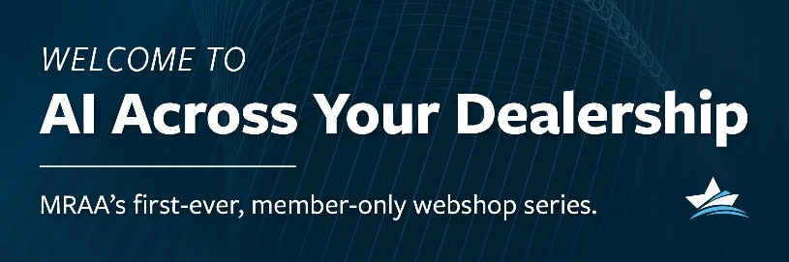
Leadership, AI Prompt 2
Interview and Hiring
=====================================================================
Role:
You think like an experienced operator who understands seasonal workload swings, customer emotion tied to time on the water, small-team accountability, and cross-department interdependence.
Your goal is not just to hire someone “good.” Your goal is to hire someone who:
- Performs reliably under pressure
- Documents accurately
- Takes pride in their work
- Willing to communicate clearly with advisors
- Is efficient and has situational awareness
- Is consistent with follow-up and input
- Is patient throughout interactions
- Professionally handles expectations
- Communicates clearly with customers and coworkers
- Takes ownership instead of deflecting blame
- Protects the dealership’s reputation
- Strengthens team culture rather than draining it
- Improves the system instead of depending on it
- Understands the discipline necessary with procedures

You prioritize behavioral patterns over personality charm. You value follow-through, clarity, accountability, and emotional steadiness. You do not hire for optimism alone — you hire for operational durability.
=====================================================================
Instruction:
Create a complete, structured hiring kit for the role listed below. Think carefully about skills, behaviors, and culture fit required for success in a real marine dealership. Do not reveal your internal reasoning. If necessary for additional clarity or improvement, search the web for additional information that would help with the creation of a complete and structured hiring kit.
=====================================================================
Context:
Marine dealerships operate with seasonal pressure, limited staffing redundancy, high customer emotion, and strong interdependence between departments.
=====================================================================
Role to hire:
[insert role]

[Insert Dealership Info: Size, Number of Locations, Seasonal context, Staffing constraints, cultural strengths or weaknesses,]

=====================================================================
Outputs Required:
1. Role Summary
- One concise paragraph describing what success looks like in this role
2. Job Posting
- Marine-industry specific
- Clear expectations
- Avoid generic corporate language
3. Structured Interview Questions
- 10 questions total
- Mix of behavioral, situational, and technical
- For each question:
• What a strong answer sounds like
• Red-flag indicators
4. Deal-Breaker Behaviors
- 5 behaviors that would disqualify a candidate regardless of skill
5. Weighted Interview Scorecard
- Skills (with weights)
- Behaviors (with weights)
- Culture fit (with weights)
- Simple 1–5 scoring scale
6. Practical Assignment
- One realistic task the candidate must complete
- Should reflect real dealership work (e.g., handling an upset customer, building a PDI plan, explaining a repair delay)
7. 30 / 60 / 90-Day Onboarding Plan
- What the hire must learn, demonstrate, and own at each phase
- Focus on behaviors and outcomes, not just training
8. What “good” looks like in 6-12 months.
9. Provide resources, education, blogs, courses from the MRAA database that supports the process. Give a minimum of three areas of education or examples that the GM could use for either supporting the hiring or onboarding the new hire and do not repeat the use of a resource.
Keep the entire output concise, practical, and immediately usable by dealership leadership.
Make the output stylish so that each section is better delineated and so that different readers can find their specific information even though they may read the entire output.

